FSD MERN - Designing and Managing Databases with MongoDB
8 days
SQL Database or RDBMS Database: MySQL
No SQL Database: Mongo Db.
Day 6:

MySQL Mongo DB
Table format json format
show databases; show databases;
show dbs;
create database databasename;
user databaseName use databaseName;
if database present it switch inside that database else if will create and switch inside that database.

Tables collections
Show tables; show table or show collections
Record document

Using below URL please download mongo db server

https://www.mongodb.com/try/download/community

after installed in window os inside C drive you can view folder directory as
C:\Program Files\MongoDB\Server\7.0\bin

using below command download mongo db shell

https://www.mongodb.com/try/download/shell

please download zip folder then extract and copy mongosh part of bin folder and paste inside server bin folder.

Please open command prompt or terminal inside a bin of server folder and run the below command as
mongosh

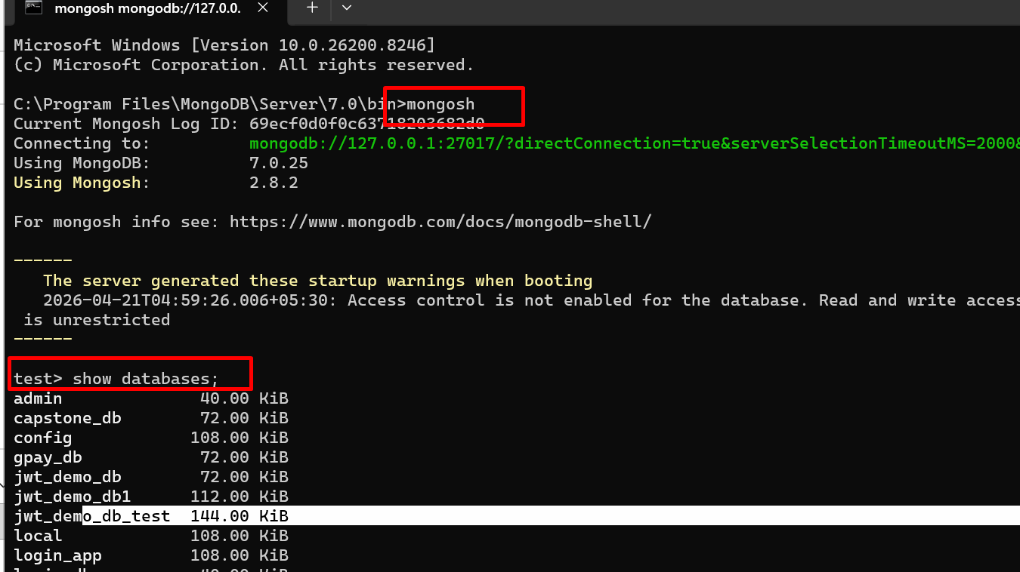

Below URL provide us online editor to do mongo db commands.
https://onecompiler.com/mongodb

Below command is use to view all databases present in mongo db.
show databases
or
show dbs

to create own or custom database
use databasename;

use test_db123;

mongo db provided pre defined object ie db which contains lot of pre defined function which help to interact with database.

Creating collection or table
db.createCollection(“Sample”); in mongo db collection name is case sensitive.

Insert the document inside a collection
db.collectionName.insertOne(JsonObject);
db.Sample.insertOne({name:"John"});
db.Sample.insertOne({name:"Raj"});
db.Sample.insertOne({name:"Steven",age:34});
db.Sample.insertOne({fname:"Ajay",lname:"Kumar"});

View the document from a collections
db.collectionName.find();

mongo db by default it create automatically pre defined property ie _id for each document. Which hold unique id for each document. It is like a PK in RDBMS.
In mongo db _id only unique property consider. If we need to pass custom value we can pass but we can’t change _id attribute.

db.Sample.insertOne({id:1,name:"John"});

